Civil war in Georgia

UNSC Resolution: | 1339
Date of adoption: | 01/31/01
Operative paragraph: | 4
Demand number: | 1339.0411

David Siroky

Wording of demand

accelerate work on the draft protocol on the return of refugees to the Gali Region and measures for economic rehabilitation, as well as on the draft agreement on peace and guarantees for the prevention and for the non-resumption of hostilities

List of addressees of the demand

Government of Georgia, Abkhazia

Short-term compliance

Description of the addressee(s)’ conduct

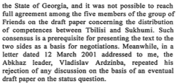

S/2001/401

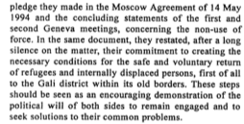

S/2001/401

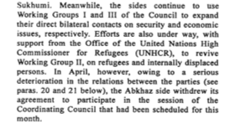

S/2001/401

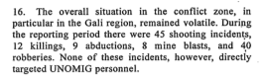

S/2001/401

S/2001/401

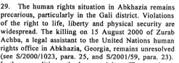

S/2001/401

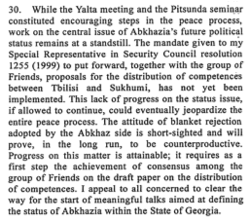

S/2001/401

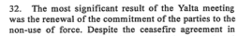
S/2001/401

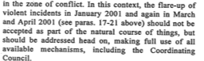

S/2001/401

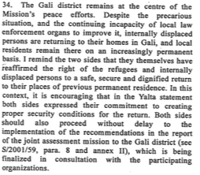

S/2001/401

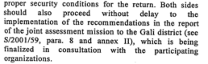

S/2001/401

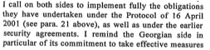

S/2001/401

Assessment

Short-term compliance
No or marginal compliance (1) | Medium low compliance (2) | Medium high compliance (3) | Full or almost full compliance (4)

Considerations underlying the assessment

Medium-term compliance

Description of the addressee(s)’ conduct

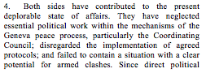

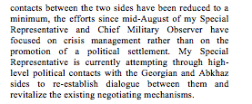

S/2001/1008

S/2001/1008

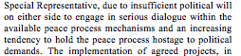

S/2001/1008

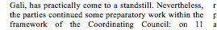

S/2001/1008

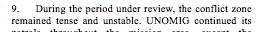

S/2001/1008

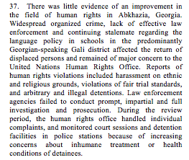

S/2001/1008

Assessment

Medium-term compliance
No or marginal compliance (1) | Medium low compliance (2) | Medium high compliance (3) | Full or almost full compliance (4)

Considerations underlying the assessment

Depth of demand

Assessment

Level of depth of demand
Low depth of demand (1) | Medium depth of demand (2) | High depth of demand (3)

Considerations underlying the assessment

Level of confidence about coding decisions

Level of confidence about coding decision
Extremely high | High | Moderate

Comments to IPI (if any)

Civil war in Georgia

UNSC Resolution: | 1339
Date of adoption: | 01/31/01
Operative paragraph: | 5
Demand number: | 1339.0511

David Siroky

Wording of demand

undertake immediate efforts to move beyond the impasse and to engage into negotiations on the core political questions of the conflict and all other outstanding issues in the UN-led peace process (in particular the Abkhaz Side)

List of addressees of the demand

Government of Georgia, Abkhazia

Short-term compliance

Description of the addressee(s)’ conduct

S/2001/401

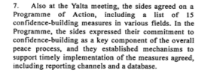

S/2001/401

S/2001/401

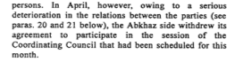

S/2001/401

S/2001/401

S/2001/401

S/2001/401

S/2001/401

S/2001/401

S/2001/401

S/2001/401

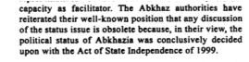

S/2001/713

Assessment

Short-term compliance
No or marginal compliance (1) | Medium low compliance (2) | Medium high compliance (3) | Full or almost full compliance (4)

Considerations underlying the assessment

Medium-term compliance

Description of the addressee(s)’ conduct

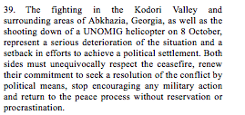

S/2001/1008

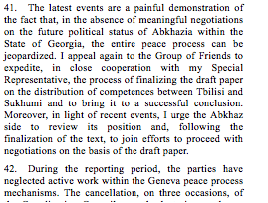

S/2001/1008

Assessment

Medium-term compliance
No or marginal compliance (1) | Medium low compliance (2) | Medium high compliance (3) | Full or almost full compliance (4)

Considerations underlying the assessment

Depth of demand

Assessment

Level of depth of demand
Low depth of demand (1) | Medium depth of demand (2) | High depth of demand (3)

Considerations underlying the assessment

Level of confidence about coding decisions

Level of confidence about coding decision
Extremely high | High | Moderate

Comments to IPI (if any)

Civil war in Georgia

UNSC Resolution: | 1339
Date of adoption: | 01/31/01
Operative paragraph: | 8
Demand number: | 1339.0811

David Siroky

Wording of demand

in the context of op. 7 of current resolution, address urgently and in a concerted manner, as a first step, the undefined and insecure status of spontaneous returnees to the Gali district, which remains an issue of serious concern

List of addressees of the demand

Government of Georgia, Abkhazia

Short-term compliance

Description of the addressee(s)’ conduct

S/2001/401

S/2001/401

S/2001/401

S/2001/401

S/2001/401

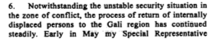

S/2001/713

Assessment

Short-term compliance
No or marginal compliance (1) | Medium low compliance (2) | Medium high compliance (3) | Full or almost full compliance (4)

Considerations underlying the assessment

Medium-term compliance

Description of the addressee(s)’ conduct

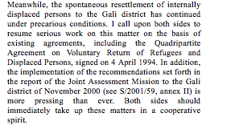

S/2001/1008

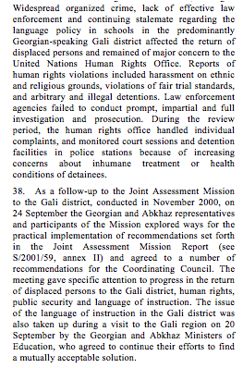

S/2001/1008

Assessment

Medium-term compliance
No or marginal compliance (1) | Medium low compliance (2) | Medium high compliance (3) | Full or almost full compliance (4)

Considerations underlying the assessment

Depth of demand

Assessment

Level of depth of demand
Low depth of demand (1) | Medium depth of demand (2) | High depth of demand (3)

Considerations underlying the assessment

Level of confidence about coding decisions

Level of confidence about coding decision
Extremely high | High | Moderate

Comments to IPI (if any)

Civil war in Georgia

UNSC Resolution: | 1339
Date of adoption: | 01/31/01
Operative paragraph: | 11
Demand number: | 1339.1111

David Siroky

Wording of demand

increase efforts at curbing the rise of criminality and armed groups in the conflict zone and to cooperate in good faith using the means provided by the Coordinating Council mechanism and investigate the recent killings of civilians and Abkhaz militiamen and bring to justice those responsible (in particular the Georgian side)

List of addressees of the demand

Government of Georgia, Abkhazia

Short-term compliance

Description of the addressee(s)’ conduct

S/2001/401

S/2001/401

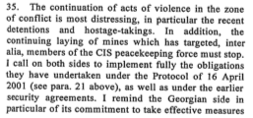
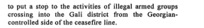

S/2001/401

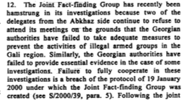

S/2001/713

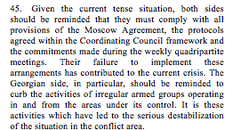

S/2001/713

Assessment

Short-term compliance
No or marginal compliance (1) | Medium low compliance (2) | Medium high compliance (3) | Full or almost full compliance (4)

Considerations underlying the assessment

Medium-term compliance

Description of the addressee(s)’ conduct

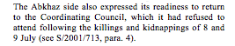

S/2001/1008

Assessment

Medium-term compliance
No or marginal compliance (1) | Medium low compliance (2) | Medium high compliance (3) | Full or almost full compliance (4)

Considerations underlying the assessment

Depth of demand

Assessment

Level of depth of demand
Low depth of demand (1) | Medium depth of demand (2) | High depth of demand (3)

Considerations underlying the assessment

Level of confidence about coding decisions

Level of confidence about coding decision
Extremely high | High | Moderate

Comments to IPI (if any)

Civil war in Georgia

UNSC Resolution: | 1339
Date of adoption: | 01/31/01
Operative paragraph: | 12
Demand number: | 1339.1211

David Siroky

Wording of demand

bring to justice the perpetrators of the hostage-taking incidents of October 1999, June 2000 and December 2000

List of addressees of the demand

Government of Georgia, Abkhazia

Short-term compliance

Description of the addressee(s)’ conduct

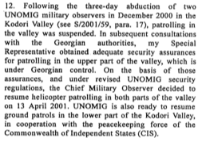

S/2001/401

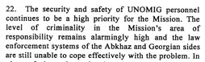

S/2001/401

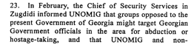

S/2001/401

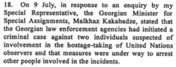

S/2001/713

Assessment

Short-term compliance
No or marginal compliance (1) | Medium low compliance (2) | Medium high compliance (3) | Full or almost full compliance (4)

Considerations underlying the assessment

Medium-term compliance

Description of the addressee(s)’ conduct

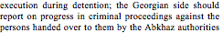

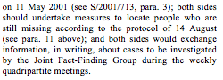

S/2001/1008

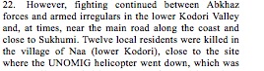

S/2001/1008

Assessment

Medium-term compliance
No or marginal compliance (1) | Medium low compliance (2) | Medium high compliance (3) | Full or almost full compliance (4)

Considerations underlying the assessment

Depth of demand

Assessment

Level of depth of demand
Low depth of demand (1) | Medium depth of demand (2) | High depth of demand (3)

Considerations underlying the assessment

Level of confidence about coding decisions

Level of confidence about coding decision
Extremely high | High | Moderate

Comments to IPI (if any)

Civil war in Georgia

UNSC Resolution: | 1339
Date of adoption: | 01/31/01
Operative paragraph: | 13
Demand number: | 1339.1311

David Siroky

Wording of demand

ensure security and freedom of movement of the UN and other international personnel

List of addressees of the demand

Government of Georgia, Abkhazia

Short-term compliance

Description of the addressee(s)’ conduct

S/2001/401

S/2001/401

S/2001/401

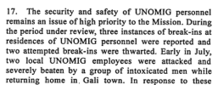

S/2001/713

Assessment

Short-term compliance
No or marginal compliance (1) | Medium low compliance (2) | Medium high compliance (3) | Full or almost full compliance (4)

Considerations underlying the assessment

Medium-term compliance

Description of the addressee(s)’ conduct

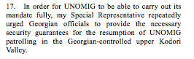

S/2001/1008

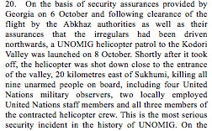

S/2001/1008

Assessment

Medium-term compliance
No or marginal compliance (1) | Medium low compliance (2) | Medium high compliance (3) | Full or almost full compliance (4)

Considerations underlying the assessment

Depth of demand

Assessment

Level of depth of demand
Low depth of demand (1) | Medium depth of demand (2) | High depth of demand (3)

Considerations underlying the assessment

Level of confidence about coding decisions

Level of confidence about coding decision
Extremely high | High | Moderate

Comments to IPI (if any)

